A WATER LEVEL INDICATOR SYSTEM FOR TANKS

GROUP MEMBERS.
NAME | REGISTRATION NUMBERS
ALEX KIUNA | BSCCS/2025/44038
JASON IGIRANEZA | BSCCS/2025/39456
MICHELE MUTHEU | BSCCS/2025/58367
MULKI ISAACK | BSCCS/2025/39591
SUMEYA MOHAMED | BSCCS/2025/43709
VERONICA NDILA | BSCCS/2025/44434
EPHRAIM KABUE | BSCCS/2025/31157
CHAPLINE KANYI | BSCCS/2025/45195
CLINTON KIPLAGAT | BSCCS/2025/43643
SYLVESTER KAGO | BSCCS/2025/44376

CHAPTER ONE: BACKGROUND.
A water level indicator system is mostly used by users to know the particular level of water for the tanks they normally use.
For our system a user gets to see their water level by a working buzzer and RG led which tells the user if the water level is either high or low whereby the RG led change colors based on the water level or a buzzer whereby it alerts the water level is high by producing some sound.
This system is used when one requires to monitor the water level indicators for their tanks.

Chapter 2: CHALLENGES ANALYSIS

2.1 CHALLENGES REGARDING WATER TANK MANAGEMENT
- Water Wastage (Overflow): A significant problem is the waste of water that occurs when tanks overflow due to an excessive water supply that goes unchecked.
- Water Shortages: Users face the problem of unexpectedly running out of water because they cannot easily determine the level of water in the tank.
- Manual Monitoring: Without an indicator, users must physically check the water level, which is inconvenient.
- Equipment Dry Running: If a tank runs empty, it can cause equipment like pumps or chillers to overheat.
- Sensor Reliability/Inaccuracy: Environmental conditions such as temperature variations or pressure changes can affect liquid level measurements, leading to inaccuracies. Also, foam and vapor formation in tanks can obstruct sensors and interfere with accurate readings.

1.2 HOW A WATER LEVEL INDICATOR CURBS THE CHALLENGES
- Prevents Overflow and Water Wastage: The system can detect when the water level goes above a certain limit, which can be used to automatically turn off the pump and prevent overflow.
- Prevents Water Shortages: When the water level goes below a set threshold, the system can notify the user or automatically turn on a pump.
- Enables Remote/Real-Time Monitoring: Indicators allow users to remotely and continuously monitor water levels via display instruments, computers, or mobile phones, eliminating the need for manual checking.
- Protects Equipment: By monitoring levels, the indicator ensures a pump is turned off before the tank runs dry, preventing damage like the overheating of a chiller.
- Optimizes Water Usage: Indicators provide data on water consumption trends and can signal abnormalities like sudden drops, which may indicate a leak, helping to optimize usage.

Chapter 2: SYSTEM COMPONENTS

2.1 Sensors
Sensor Type | Principle/Mechanism | Typical Application/Details
Conductivity/Probe Sensors | Uses probes (metal contacts) placed at different levels to detect water. Water acts as a conducting medium to complete a circuit when it reaches a probe. | Used in simple electronic indicators with LEDs and buzzers to signal high, moderate, and low levels.
Ultrasonic Level Sensor | Non-contact sensor that emits ultrasonic signals and calculates the liquid level by measuring the echo time. | High accuracy (\pm1\text{ cm}) and suitable for clean water, rainwater, and sewage, avoiding corrosion.
Hydrostatic Pressure Sensor | Measures the pressure exerted by the water column to calculate the liquid level height. | Strong anti-interference capability, low cost, and suitable for underground or enclosed water tanks.
Float-Type Level Switch | Uses a buoyant float that rises and falls with the liquid, actuating a reed switch or potentiometer. | Simple structure, reliable, and suitable for most conventional storage scenarios.

2.2 Controllers and Control Unit
Component | Role | Usage/Operation
Control Unit / Microcontroller | The core processing part that receives signals from sensors and processes the data. | Processes sensor information to determine the water level and then triggers the output display or pump control. Examples include circuits with transistors (like BC547) or ICs (like ULN2003 or CD4511/74HC147).
Wireless Pump Controllers | Devices that wirelessly manage the pump connected to the tank. | Used for remote control of the pump, often integrated with a cloud-based system.

2.3 Output Devices
Component | Function | Usage/Operation
LED Indicators | Provides a visual indication of the water level status. | LEDs of different colors (e.g., green for low, yellow for half, red for full) light up to show the current water level.
Buzzer/Alarm | To signal when the water level has reached a critical point (usually full). | Sounds a beep to alert the user when the tank is full, helping to prevent overflow.
Display Instruments (e.g., LCD, 7-Segment) | To show the water level in a precise, numerical, or visual format. | Shows the fill level in percentages or numerical steps from empty (0) to full (9).

TINKER CAD DESIGN CIRCUITS

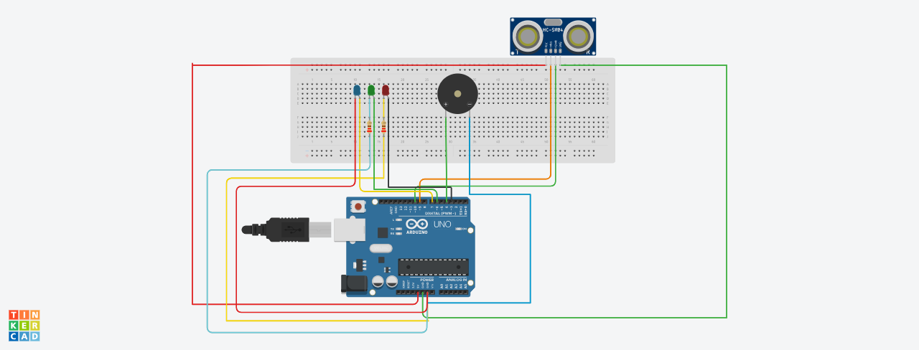

CODES
#define TRIG 9
#define ECHO 10
#define RED_LED 3
#define GREEN_LED 4

long duration;
int distance;

void setup() {
pinMode(TRIG, OUTPUT);
pinMode(ECHO, INPUT);
pinMode(RED_LED, OUTPUT);
pinMode(GREEN_LED, OUTPUT);
Serial.begin(9600);
}

void loop() {
// Send ultrasonic pulse
digitalWrite(TRIG, LOW);
delayMicroseconds(2);
digitalWrite(TRIG, HIGH);
delayMicroseconds(10);
digitalWrite(TRIG, LOW);

// Read echo
duration = pulseIn(ECHO, HIGH);
distance = duration * 0.034 / 2; // Convert to cm

Serial.print("Distance: ");
Serial.print(distance);
Serial.println(" cm");

// Tank FULL
if (distance < 5) {
digitalWrite(GREEN_LED, HIGH);
digitalWrite(RED_LED, LOW);
}
// Tank LOW/EMPTY
else if (distance > 20) {
digitalWrite(GREEN_LED, LOW);
digitalWrite(RED_LED, HIGH);
}
// Normal level
else {
digitalWrite(GREEN_LED, LOW);
digitalWrite(RED_LED, LOW);
}

delay(500);
}

